|  |
| --- |
| NAME: Jagath Haren  USN: 4AL17CS034 |

Write Scheme Diagram and Complete ER Diagram

1. Consider the following relations:  
   Student (snum: integer, sname: string, major: string, level: string,age: integer)  
   Class (name: string, meets at: string, room: string, d: integer)  
   Enrolled (snum: integer, cname: string)  
   Faculty (fid: integer, fname: string, deptid: integer)  
   The meaning of these relations is straightforward; for example,  
   Enrolled has one record per student-class pair such that the student  
   is enrolled in the class. Level is a two character code with 4 different values (example: Junior: JR etc)

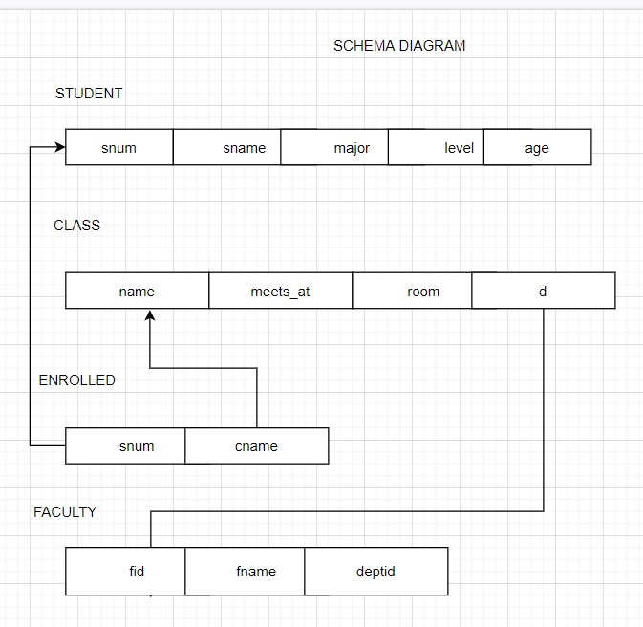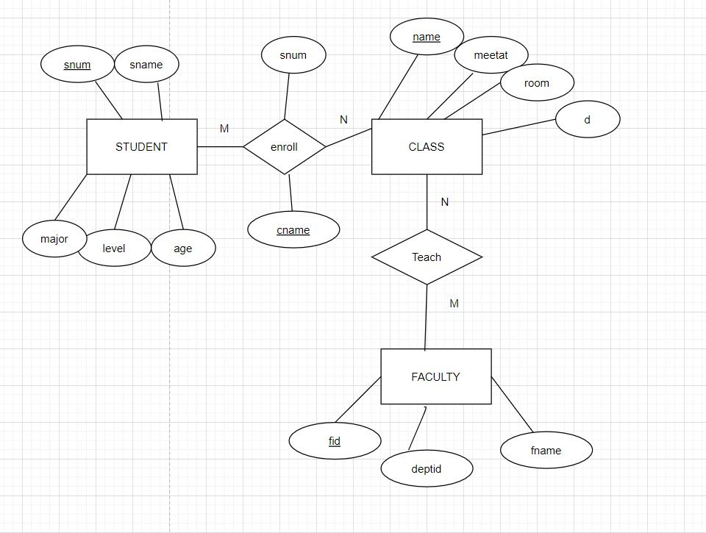

1. Consider the following database for a banking enterprise  
   BRANCH(branch-name:string,branch-city:string,assets:real)  
   ACCOUNT(accno:int,branch-name:string,balance:real)  
   DEPOSITOR(customer-name:string,accno:int)  
   CUSTOMER(customer-name:string,customer-street:string,city:string)  
   LOAN(loan-number:int,branch-name:string,loan-number-int)  
   BORROWER(customer-name:string,customer-street:string,city:string)

